# Welcome

Are you wanting to bridge diversity and promote tolerance and respect in your school and community? Is the development of SMSC a key target in your new school improvement plan? Are your pupils fully prepared for life in a culturally diverse modern Britain?

The recent Government ***Integrated Communities Strategy******Green Paper*** sets out an ambitious programme of actions designed to build strong integrated communities, where people – whatever their background – can live, work, learn and socialise together, based on shared rights, responsibilities and opportunities. To read the plan in full follow this link:

[**https://www.gov.uk/government/consultations/integrated-communities-strategy-green-paper**](https://www.gov.uk/government/consultations/integrated-communities-strategy-green-paper)

**As a subject that explores different faiths and cultures, RE is ideally placed to promote positive community relations, interfaith respect and understanding. Throughout this newsletter there are resources that can provide a starting point.**

**Diversity of Religion and Belief**[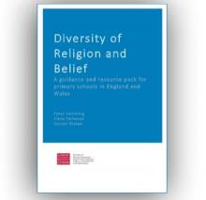](http://clicks.retoday-email.co.uk/email/S-1424@36549@aJCGSyowCsaT3DUww388RwvkclsbzrDhnT-t3vZZxoo.@)

**A free guidance and resource pack for primary schools in England and Wales**

Cardiff University’s School of Social Sciences has produced a free guidance and resource pack for primary schools entitled Diversity of Religion and Belief. The pack aims to provide schools with the tools to create an environment that recognises and values diversity of religion and belief, as well as delivering good quality RE that promotes interfaith respect and understanding.

[**http://orca.cf.ac.uk/110147/?utm\_source=emailmarketing&utm\_medium=email&utm\_campaign=primary\_may\_2018\_newsletter\_with\_download&utm\_content=2018-06-12**](http://orca.cf.ac.uk/110147/?utm_source=emailmarketing&utm_medium=email&utm_campaign=primary_may_2018_newsletter_with_download&utm_content=2018-06-12)

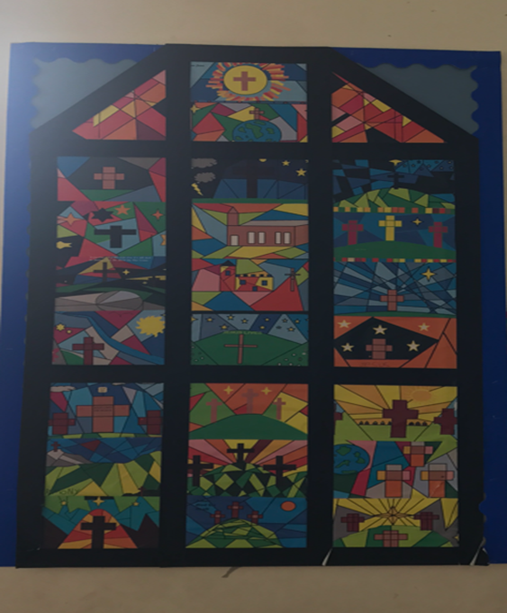RE curriculum week

**Interested in planning an RE curriculum week?**

Each spring term, Edenfield CE Primary delivers an RE theme week to celebrate world faiths and cultural diversity in their community. Highlights are as follows:

The children in Reception and Y6 enjoyed learning more about Christianity. In Reception they listened to stories that Jesus told including the Good Samaritan, and the Prodigal son and had the opportunity to visit Edenfield Parish Church with their Year 6 buddies.  They then enjoyed creating their own role-play church back in class, where lots of weddings and christenings took place.   Year 6 studied Christianity through stained glass windows. The children looked at famous stained glass windows and how they were used historically as a method of storytelling. The children created pictures of their own stained-glass windows to tell different stories from the Bible.

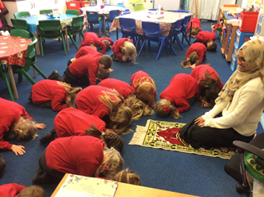

Year 1 learned all about the religion of Islam. This included learning about the five pillars of Islam and the Hajj Pilgrimage. Role play activities included acting out what to do when arriving in Mecca. Year 1 now know all about the five daily prayers which must be done at certain times of the day, and the different steps taken when using a prayer mat.

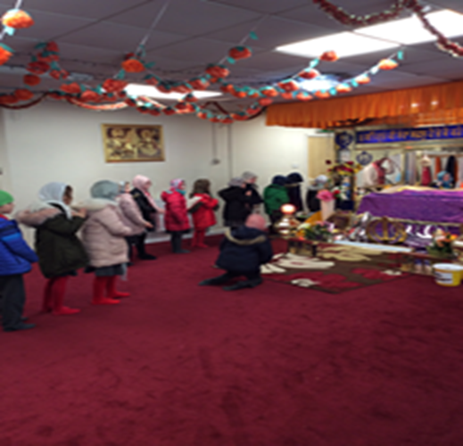Class 2 focused on Sikhism. The children learned all about how Sikhism was formed, symbols of Sikhism, the 5Ks and where Sikhs worship. Pupils went on a trip to a Sikh Gurdwara in Preston where they had to wash their hands, remove their shoes and cover their hair before entering the main prayer room. Everyone had to kneel in front of the Guru Granth Sahib which is the name of the Holy Book. It was a really enjoyable, interesting trip and everyone learned something new about Sikhism.

Class 3 have been learning about Buddhism and thinking about meditation. Meditation is used to focus the mind and forget about the distractions faced in life. The children enjoyed listening to calm music as well as instructions to help them concentrate. They also learnt about some of the different hand positions (Mudras) that Buddhists use when meditating.

Class 4 studied Hinduism. Throughout the week, the children looked at the origins of Hinduism; focused on the different Gods; created Mehndi designs; painted Rangoli patterns; and participated in Hindu dancing.

Finally Class 5 focused on Judaism. The children studied ‘Shabbat’ and the synagogue.  On the Friday of RE week, Class 5 was lucky enough to visit the Jewish Museum in Cheetham Hill to see all of the parts of the synagogue first hand. The children got to act out a religious ceremony and dress up in the prayer shawl (Tallit) and study Torah scrolls. They were told the story of the Passover, with props, to make the re-telling interactive and engaging.

The week culminated in a whole school celebration assembly whereby each class told the rest of the school about the different religions that they had been studying.

Year 6 also took their reception buddies to church where they gave them a tour and explained about the different parts of the church.

RE week continues to be one of the highlights of the school year at Edenfield and the children enjoy these projects enormously. Interested in doing something similar? Give Charlotte Garner, headteacher a ring at Edenfield to learn more.

|  |
| --- |
| ***Wanting to know what is happening nationally in RE? The final report on the Commission on Religious Education will be released in September 2018. Well worth a read.*** |

Resources, Planning and Assessment

|  |
| --- |
| ***New Resources to support the planning and assessment of Religious Education in Lancashire.***  You will be pleased to know that there are now three assessment grids uploaded to the RE website: Christianity, Islam and Hinduism. These aim to support schools in making age related judgements.    **Also uploaded, is also a new long term curriculum map to support the progressive teaching of knowledge and skills – to download please see the planning section of the website.** |

Feel that you can contribute to the development of RE across Lancashire?

**Looking to develop new skills, learn from others and gain experience in other contexts?**

**Then consider applying to join our pool of associate RE consultants!**

An exciting opportunity has arisen for experienced Lancashire primary or secondary teachers. Due to the increasing demand for support in delivering the Lancashire Agreed Syllabus for RE, agreement has been given to add to the pool of existing RE associate consultants.

Consultants will be trained to:

* Provide 1: 1 support for teachers and subject leaders
* Deliver school based INSET both within and outside Lancashire.
* Organise Pupil Voice events
* Deliver marketed courses.
* Lead local network meetings
* Work as a team to develop new materials.

We would ask that Headteachers release the successfully appointed teachers to the pool initially for up to 5 days/ term as and when required by prior agreement. This request would be in response to demand and would be subject to the experience and skills required to support the request.

Schools would be reimbursed for the release of their member of staff at a rate of £450 per day which would also include an element for travel expenditure that may be incurred by the teacher.

Supply cover at £165.00 per day will be provided for attendance at REC meetings, training sessions and when working as a team to write new materials.

If you feel that you or a colleague would be suitable for this opportunity approval is required from your headteacher.

Please contact [Alison.Lloyd@Lancashire.gov.uk](mailto:Alison.Lloyd@Lancashire.gov.uk) for an expression of interest form. Closing date 13th July 2018. 

Opportunities and Inspiration

***Summer RE Training Opportunity***

**Teaching Islam in Primary Schools**

**Date: 10th July 2018 1.30 – 4.30pm**

**Venue: Quwwat Ul Islam Mosque, Peel Hall Street, Preston, PR1 6QQ**

**Reference: REL 101**

This course will be beneficial to teachers and leaders of RE and help build confidence in the planning and delivery of lessons about the Islamic faith. It is suitable for both new and experienced teachers. There will be an opportunity to discuss the new progression grids for RE and how these might be implemented in the classroom.

***Book a place via the LPDS website***

**Westhill Awards**

**Wanting some inspiration? Take a look at the work of other schools by exploring the "Projects that Spark" section of the Westhill Endowment site:**

<http://www.westhillendowment.org/projects-that-spark>

**The Shared Space Project**

Academics from the University of Bristol joined forces with the National Association of Teachers of Religious Education (NATRE) in the [**Shared Space Project**](http://www.natre.org.uk/about-natre/projects/the-shared-space-project/) to explore the best ways of promoting tolerance and understanding within RE lessons.

To download the toolkit:

<https://www.natre.org.uk/news/latest-news/how-re-lessons-can-reduce-prejudice-and-improve-community-relations/?utm_source=emailmarketing&utm_medium=email&utm_campaign=primary_may_2018_newsletter_with_download&utm_content=2018-06-12>

[](https://www.bing.com/images/search?view=detailV2&ccid=zUYhbFKC&id=A640A1740F0E082F2E495C593778F92466606570&thid=OIP.zUYhbFKCLp-zqrYIHP5XkgHaHB&mediaurl=http://dapstl.org/wp-content/uploads/2012/10/interfaith-calendar.jpg&exph=612&expw=646&q=interfaith&simid=608049367273572921&selectedIndex=27)

*Lost your password for the RE website?*

*Can't download the exemplar plans and support materials?*

*Please send an email to:*

[*advisory.support@lancashire.gov.uk*](mailto:advisory.support@lancashire.gov.uk)

Better RE in Lancashire

|  |
| --- |
| C:\Users\mfinch005\AppData\Local\Microsoft\Windows\Temporary Internet Files\Content.Outlook\LBEQ6KAU\33135324_1987875981476883_3746200866483339264_n.jpgIn May, primary school teachers from across Lancashire attended an all-day conference with **Lat Blaylock** looking at how to teach better RE and put it into practice. The course was a great success and all involved felt inspired and confident to try out new ideas including experiential learning. Teachers were encouraged to take risks and try out Big RE as a whole school incentive to promote work across the curriculum. Exemplars of work were provided to see theory into practice.  Feedback from those who attended was very positive, describing the day as giving “*Practical ideas for making RE engaging for children and making RE purposeful” “Great informative day with lots of amazing ideas”.*  The course was thoroughly enjoyed by all and many commented on how they are looking forward to sharing, planning and trying out the new ideas within their schools. **Interested? A second day with Lat Blaylock is planned for 30th October at Farington Lodge. Please see LPDS for details.** |

Tackling Radicalisation

Young people from Blessed Trinity RC College and Marsden Heights Community College took part in a project tackling radicalisation. The project was led by the Faith Centre and delivered in partnership with the Burnley Youth Theatre. To watch the documentary and the film click on the links below.

<https://m.youtube.com/watch?v=2Ou2J833oII>

<https://m.youtube.com/watch?v=JQAeksG-8cs>

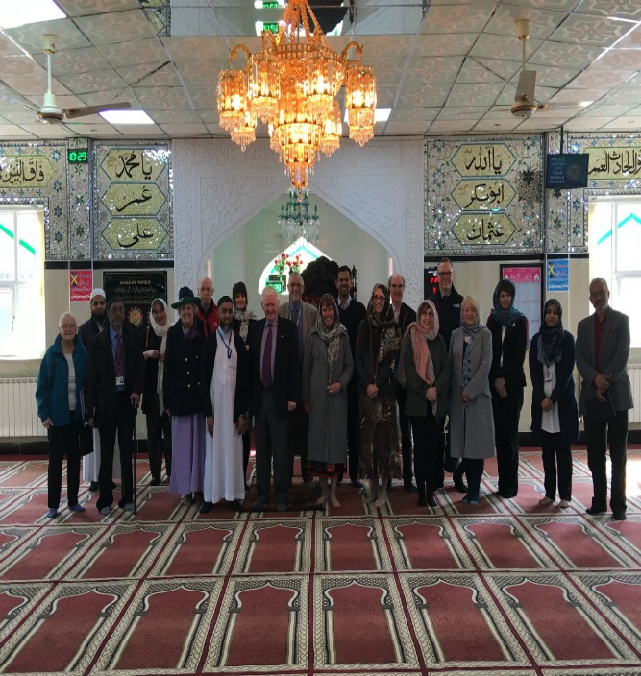SACRE Visits…

***What have your SACRE members been up to?***

The most recent Lancashire SACRE meeting was held on the 30th April 2018 at the Ghausia Mosque on Abel Street, Burnley.

During this visit all the members were given a guided tour of the mosque and also visited the Faith Centre which is situated within walking distance.

All the members would like to thank everyone at Ghausia Mosque for their hospitality throughout.

Free Area Network Meetings

**Unsure how to form assessment judgements in Religious Education?**

**Try out these FREE Area Network Meetings 4.00 -5.30pm**

These FREE area network meetings are being provided to support teachers in forming judgements when assessing age related expectations in Religious Education.

There will be opportunities for teachers to bring along samples of work and use the new assessment grids to moderate judgements with the support of the RE consultants and other local teachers. Hopefully this will allow schools to gain greater confidence in their attainment data prior to submission to the Local Authority.

Teachers will also have opportunity to consider Religious Education updates, share good practice and discuss challenges and dilemmas.

Venues:

**East:** Hapton CE (VC) Primary School - **Tuesday 19th June**

**North:** Bowerham Primary & Nursery School - **Monday 18th June**

**South:** Lea Community Primary School - **Tuesday 5th June**

**Ref: REL 102**

**NATRE

*Following on from their* **‘State of the Nation’ Report** published in September '17, NATRE are interested in capturing the views of primary teachers about Religious Education.

Information from the survey will be used to campaign with the DfE for additional support to ensure quality teaching and provision in RE.

Please complete this survey and encourage your colleagues and networks to do the same. As a thank you for completing the survey, you get £5 to spend with RE Today.

<https://retoday.org.uk/news/natre-primary-survey-2018>



Spirited Arts

***Looking for something fun to get involved with in the summer term?***

*Why not enter the NATRE Spirited Arts competition?*

In its 15th year, this competition has attracted over 320,000 participants (averaging 20,000 per year!) since 2004, with 2,000 entries being sent in to NATRE each year for judging. The annual competition starts at the beginning of every school year and runs through to 31 July, in order to enable teachers to incorporate the art competition into their RE lessons. Many schools have an ‘Art in Heaven’ unit of work, or a special learning RE/arts week.

To see the themes for 2018 and how to enter please see <https://www.natre.org.uk/about-natre/projects/spirited-arts/spirited-arts-2018/>

Upcoming Festivals

**Festivals June and July 2018**

**15th June – Eid-ul-Fitr Feast of Fast Breaking**

**16th June – Martydom of Guru Arjan Dev (Sikh)**

**21st June – Summer Solstice**

**21st June – World Humanist Day**

**24th June – Midsummer Day**

**14th July – Ratha Yatra (Hindu)**

**15th July – Chokor (Buddhist)**

**22nd July – Tisha B'Av (Jewish)**

**27th July – Dhamma Day (Buddhist)**

**Needing Help?**

**Finding the Agreed Syllabus a challenge? Not sure how to assess in RE? Needing to increase subject knowledge of a specific religion? Wanting to raise the profile of RE in your school? Committed to developing the effectiveness of the subject leader for Religious Education?**

**Our consultants can offer 1:1 support for individual teachers and school based INSET in addition to running marketed courses. Normal consultancy rates apply.**

**To make an enquiry please contact:** [**advisory.support@lancashire.gov.uk**](mailto:advisory.support@lancashire.gov.uk)